Title of Your Article
Author 1¹⁾, Author 2²⁾, and Author 3³⁾
¹⁾ Department, Institution/Company, Town, State/Country,
²⁾ Department, Institution/Company, Town, State/Country
³⁾ Department, Institution/Company, Town, State/Country
Email address of corresponding author
Summary: Clearly state what is new in this first paragraph. The degree of novelty and clearness will be some of the major evaluation criteria in the review process. Relate your work to what has been already done. This section should describe your major achievements and represent a summary and conclusions of your contribution in a nutshell. Please don't submit papers that have already been published elsewhere. A maximum of 200 words should be appropriate for this section.
Keywords: Provide a maximum of five keywords here.

Introduction
Here is some space to describe the background of your work. Cite references using brackets [1]. You may refer to the figures if appropriate to illustrate basic structures, device designs etc. (Fig. 1) not forgetting to describe what the reader should read out of this figure.
Fig. 1: One-column figure example. Briefly characterize here the main idea of the figure.

Results
It is mandatory to present sample results in your abstract. Illustrate your approach and latest results by referring to figures as demonstrated here (Fig. 2 and Fig. 3). Clearly distinguish between already obtained results and those you might expect during the course of your work and eventually include in the final paper.
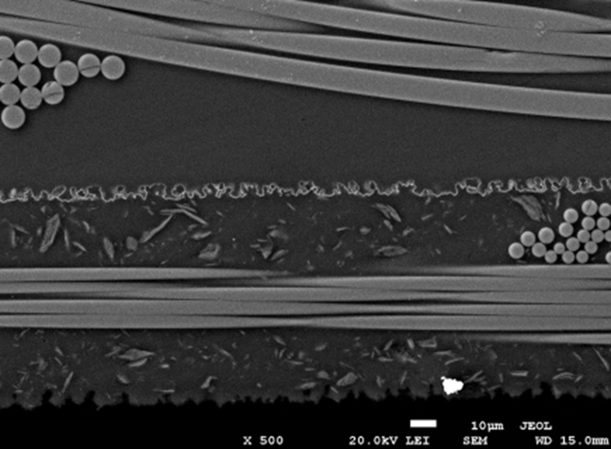 | 
Fig. 2: Example of two figures simply placed in an invisible two-column table. | Fig. 3: You can use automatic fitting by first preparing this table and then by drag-  and-dropping your graphic e.g. from the  clip board into the respective table field.
If you want to include photographs or other bitmaps please proof that the resolution is appropriate for the final size (e.g. 200 to 300 dpi in the final size) and all labeling is readable.
Underline the presenting author and make sure that the email address of the corresponding author is provided.
If you don’t use this MS-Word template, please adhere to the style as closely as possible. In particular, do not change the page type area (paper format: DIN A4 = 297 x 210 mm. Upper and bottom margin: 25 mm, outer margin: 20 mm, inner margin: 25 mm). Otherwise you risk cutting.

Acknowledgement

References
- P. Firek, "Title", J. Appl. Phys. vol. 38 no. 1 (2016 ) pp. 33-44

